CRM Application for Wholesale Rice Mill

Leveraging Salesforce to Improve Efficiency in Rice Mill Operations

Prepared by: Yash Yadav

Date: 23-08-2024

# Abstract

This report introduces a robust CRM system designed to enhance daily operations within a wholesale rice mill. The application leverages Salesforce to deliver comprehensive reports, summary fields, cross-object formula fields, validation rules, and permission sets, all aimed at boosting efficiency and optimizing resource management.

# Introduction

The wholesale rice milling industry encounters multiple challenges related to operational management, customer engagement, and reporting. This project aims to create a powerful CRM application using Salesforce, simplifying the management of daily rice production, sales, and analytics. By harnessing the capabilities of Salesforce, the application enhances customer satisfaction, improves store processes, and increases overall productivity in the rice mill.

# Project Objectives

-> Develop an intuitive CRM application.

->Streamline daily operations and reporting.

->Improve customer experiences and optimize

resource management.

# Description

The application is built on the Salesforce platform, employing custom objects, fields, and relationships for efficient data management. The system architecture includes:

Custom Objects: Supplier, Rice Mill, Consumer, Rice Information

Fields: Numeric fields, rollup summary fields, cross-object formula fields

Relationships: Master-Detail relationships

User Interface: Custom Tabs, Page Layouts, Lightning Application

Security: Validation Rules, Permission Sets

# Features and Functionality

## Reporting and Dashboards

The system generates comprehensive reports and analytics on daily rice sales, overall income, revenue, popular offerings, and consumer purchasing trends. These insights enable the rice mill owner to analyze data, optimize resource usage, and make informed future decisions.

## Rollup Summary Fields

These fields consolidate data from child objects to parent objects in a master-detail relationship. They utilize COUNT, SUM, MIN, and MAX functions. For example, the system displays the total rice value supplied from the rice details object on the related supplier record.

## Cross-Object Formula Fields

Cross-object formula fields allow referencing fields from another Salesforce object. For instance, the system can calculate the total payment due by applying a formula: *Quantity of rice ordered* × *price per kilogram*.

* Validation Rules

Validation rules ensure data accuracy by displaying error messages when invalid inputs are entered. For instance, the IsBlank formula checks if a field is empty and generates an error message if necessary.

## Permission Sets

Organization-Wide Defaults (OWD) are employed to limit access. Roles are defined so that the owner has visibility into both employee and worker records, while employers can only view worker data.

# Implementation Steps

# 

## Prerequisites

-> Salesforce Developer account

-> Proficiency in Salesforce admin concepts

-> Installation of two web browsers

-> Reliable internet connectivity

Milestones and Activities

## 1. Create Developer Account

* Sign up for a Salesforce Developer account.

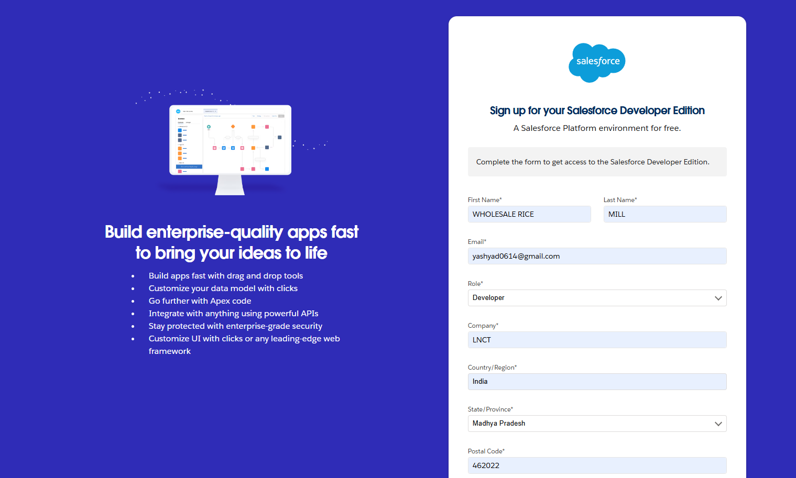

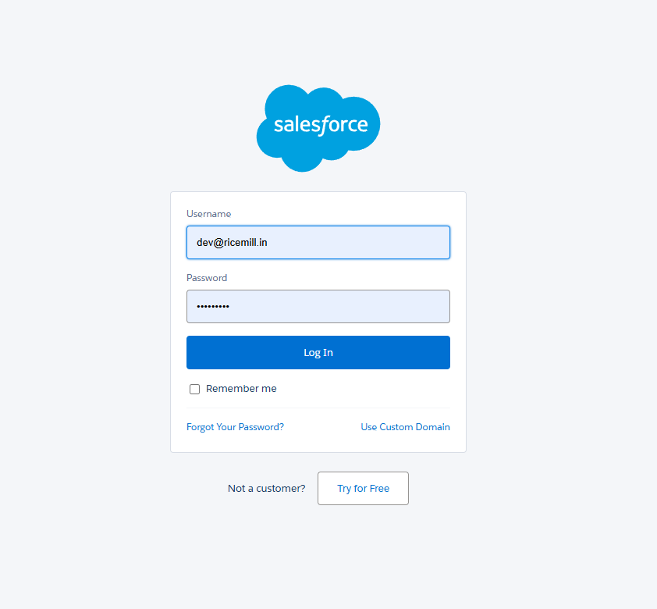

## 2. Creating Objects

● Supplier Object: Manage supplier details.

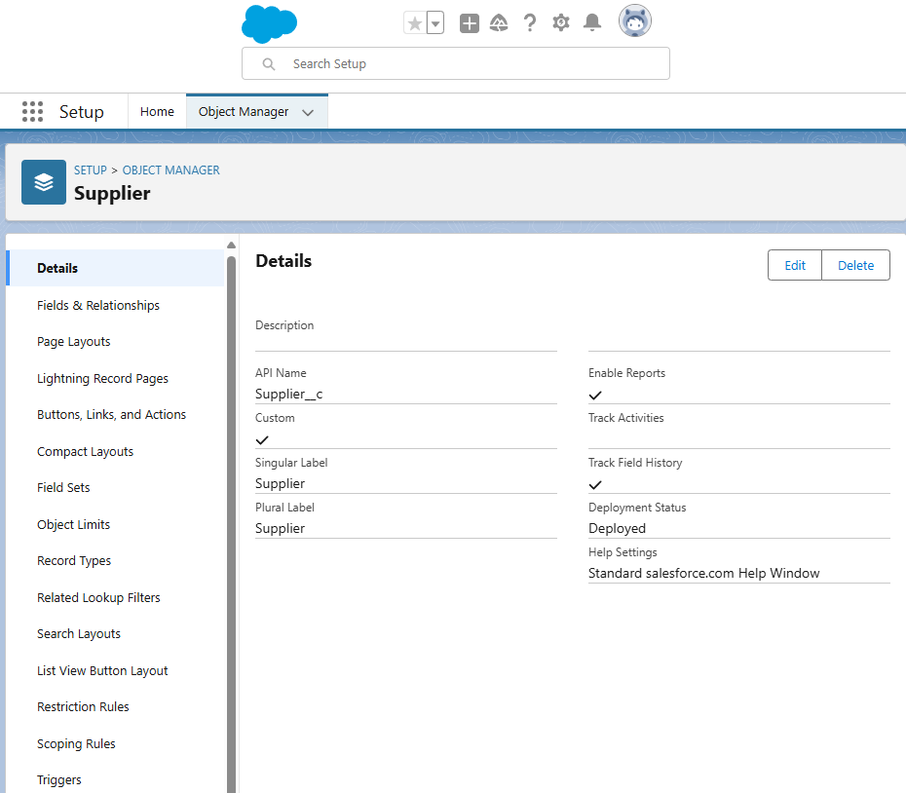

● Rice Mill Object: Manage rice mill details.

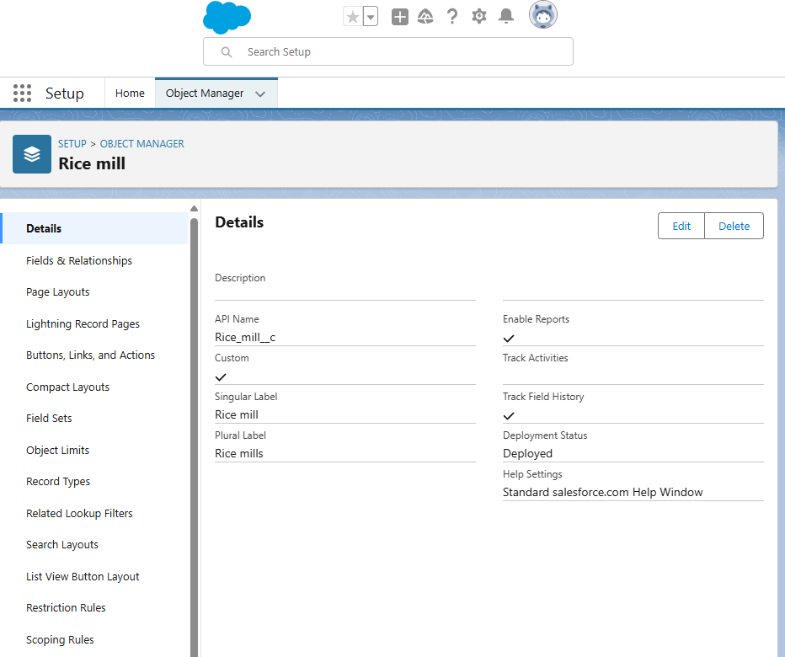

● Consumer Object: Manage consumer details.

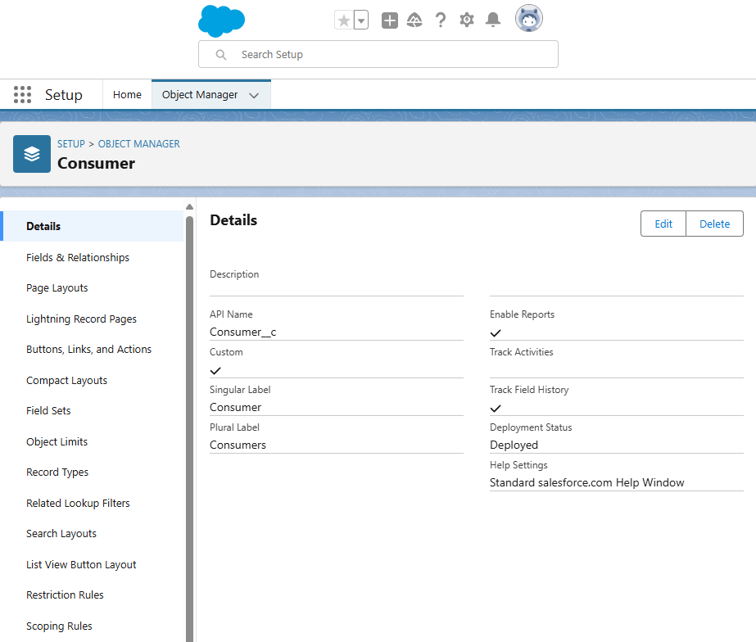

● Rice Details Object: Track rice production and sales.

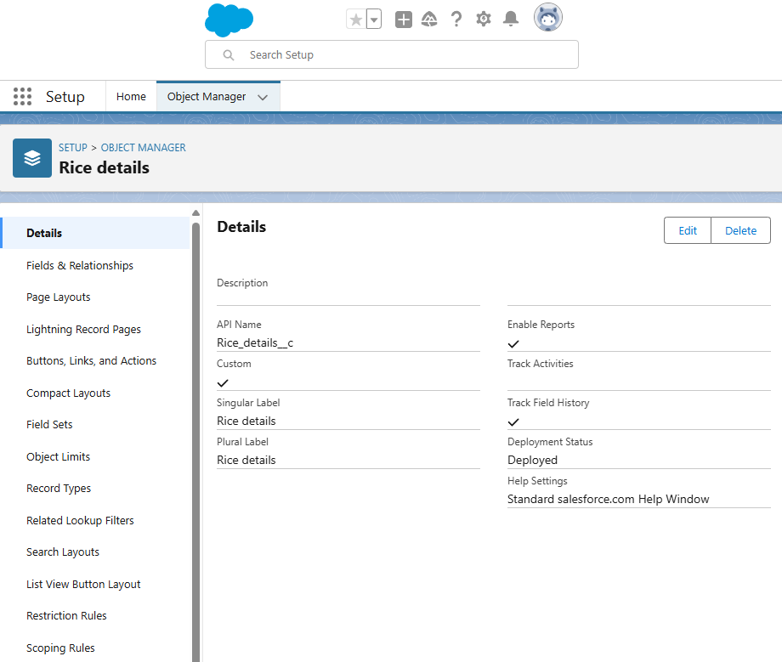

## 3. Creating Tabs

● Create custom tabs for each object to easily access data.

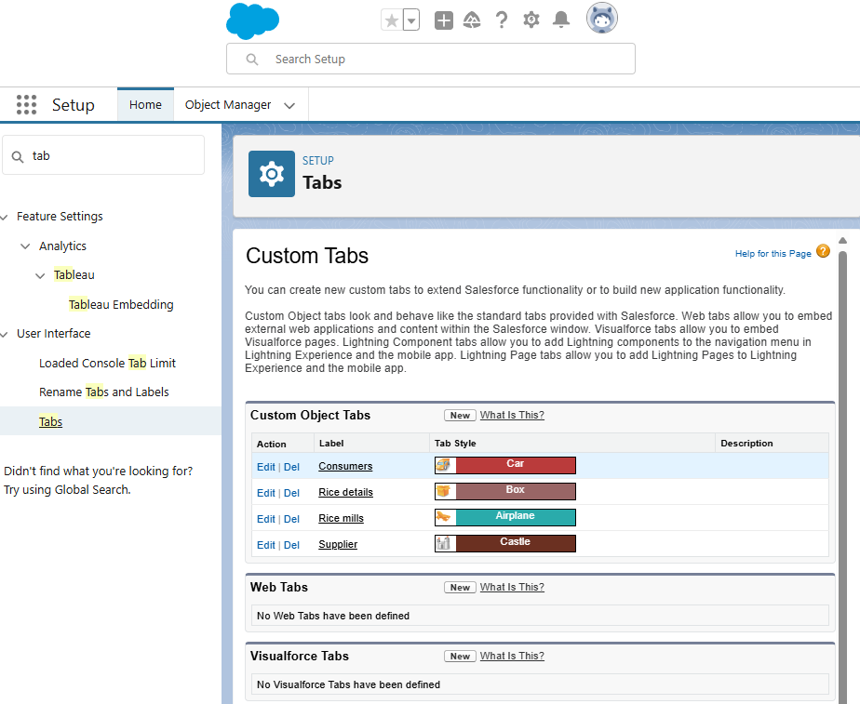

## **4. Creating Lightning App**

● Steps to create a Lightning app for the CRM application.

## 5. Creating Fields

● Number fields: Track quantities and prices.

● Rollup Summary Fields: Summarize data from child to parent objects.

● Cross-Object Formula Fields: Calculate total amounts.

● Validation Rules: Ensure data integrity.

## 6. Creating Page Layouts

● Customize page layouts for each object to enhance user experience.

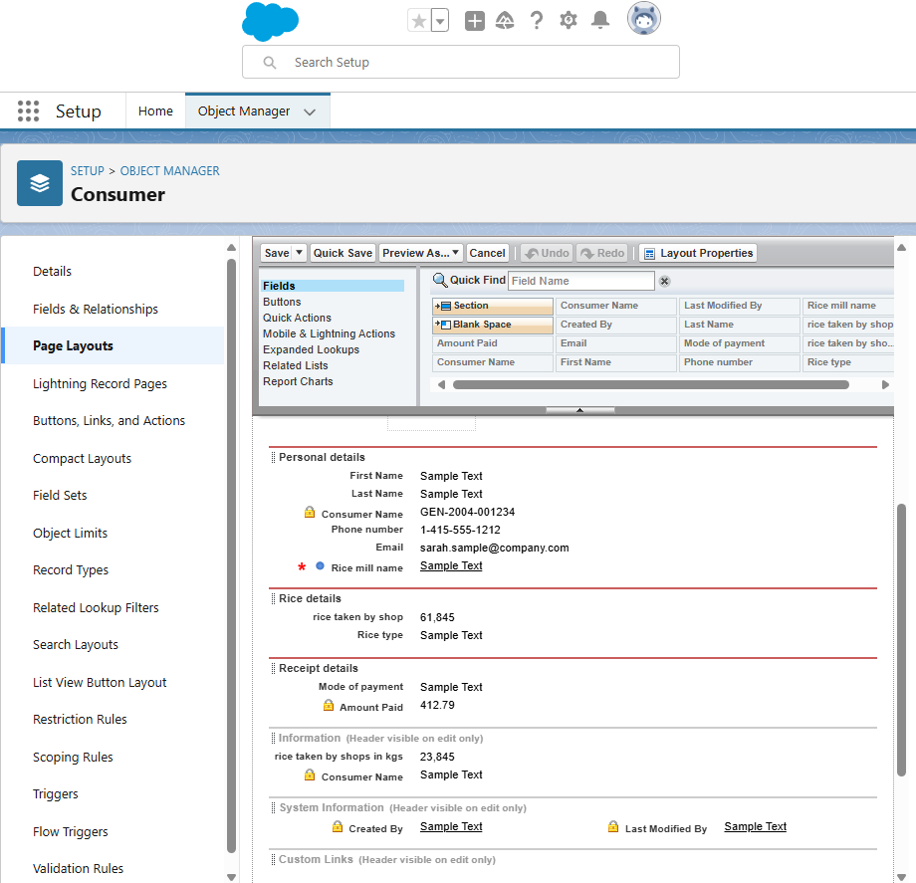

## 7. Creating Profiles, Roles, and Role Hierarchy

● Define profiles to control user permissions.

● Create roles and set up a role hierarchy to establish data access levels.

## 8. Creating Users

● Add users to the Salesforce organization and assign appropriate profiles and roles.

## 9. Creating Permission Sets

● Define permission sets to grant additional permissions to users beyond their profile.

## 10. Creating Reports

● Create detailed reports to track rice production, sales, and other key metrics.

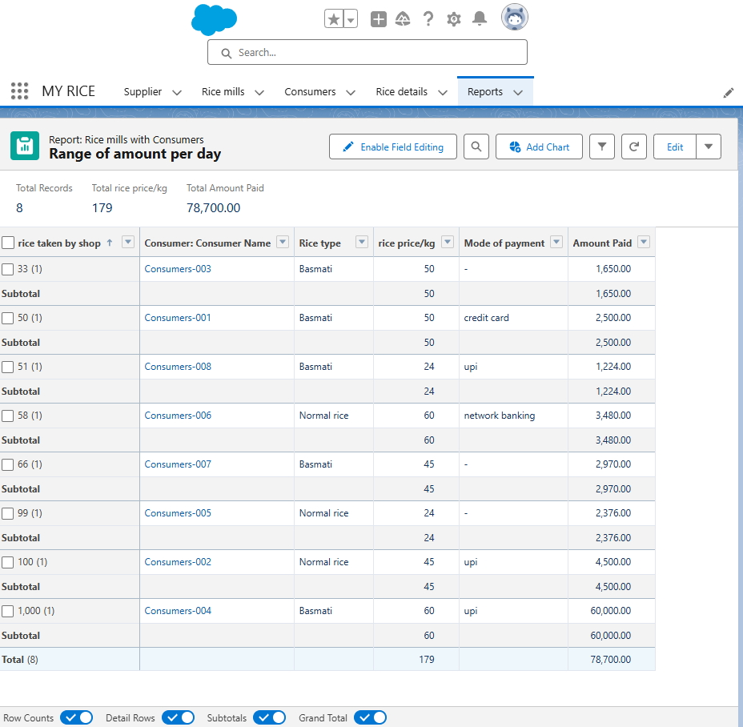

11. Creating Dashboards

● Design dashboards to provide visual summaries of key metrics and reports.

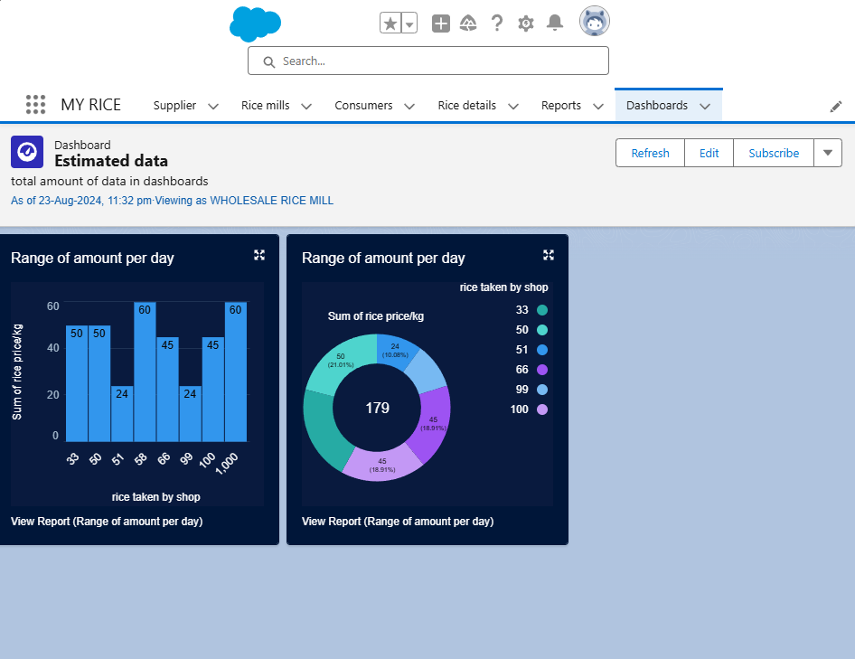

# **Conclusion**

The CRM application successfully streamlines daily operations in the rice mill, enhancing efficiency and customer satisfaction. Future enhancements could include integrating the application with external systems for broader functionality.

References

● Salesforce Documentation

● Community Forums